**DAILY ONLINE ACTIVITIES SUMMARY**

|  |  |  |  |  |  |  |  |  |
| --- | --- | --- | --- | --- | --- | --- | --- | --- |
| **Date:** | **23-05-2020** | | | | | **Name:** | **Javahar.S.Goutham** | |
| **Sem & Sec** | **6th A** | | | | | **USN:** | **4AL16CS132** | |
| **Online Test Summary** | | | | | | | | |
| **Subject** | | **No test** | | | | | | |
| **Max. Marks** | | **nil** | | **Score** | | | **nil** | |
| **Certification Course Summary** | | | | | | | | |
| **Course** | **Introduction to ethiccal hacking** | | | | | | | |
| **Certificate Provider** | | | **Great Learning** | | **Duration** | | | **6 hrs** |
| **Coding Challenges** | | | | | | | | |
| Problem Statement: 1. Write a C Program to Generate First N Triangular Numbers (Where N is read from the Keyboard).  2. Write a menu program in Python to find Area-Circle, Circumference-Circle, Area- Square, Circumference-Square using functions with menu choice.  3. Python program in number right angled triangle. | | | | | | | | |
| Status: **YES, Completed all Programs** | | | | | | | | |
| **Uploaded the report in Github** | | | | | **YES** | | | |
| **If yes Repository name** | | | | | <https://github.com/alvas-education-foundation/goutham-dotcom> | | | |

Online Test Details: (Attach the snapshot and briefly write the report for the same)

No test was given on this day

Certification Course Details: (Attach the snapshot and briefly write the report for the same)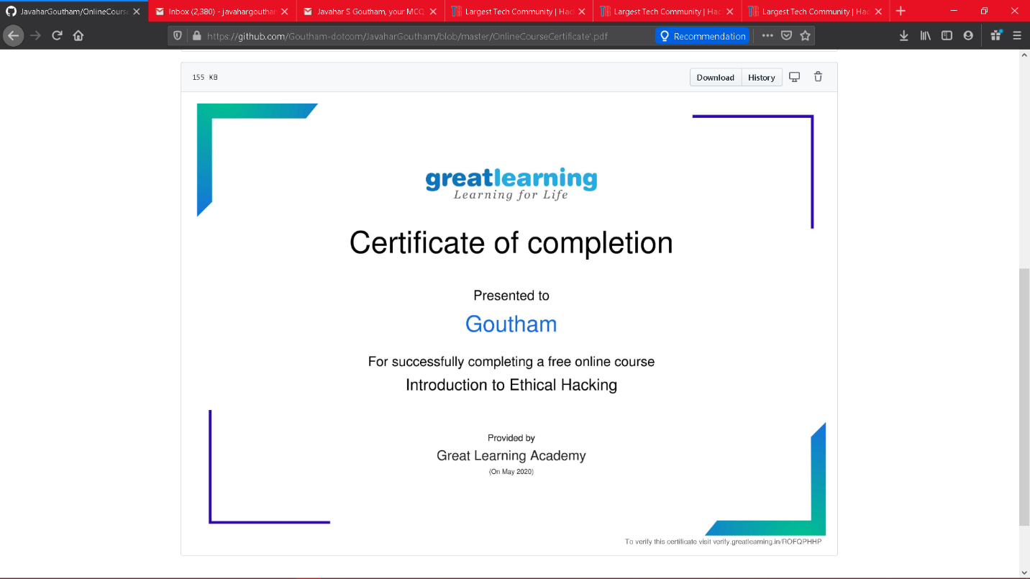

The above course is being taken up by me which is based on the Introduction to ethical hacking The details of the course and certificate provider is mentioned in the above form.

.

Coding Challenges Details: (Attach the snapshot and briefly write the report for the same)

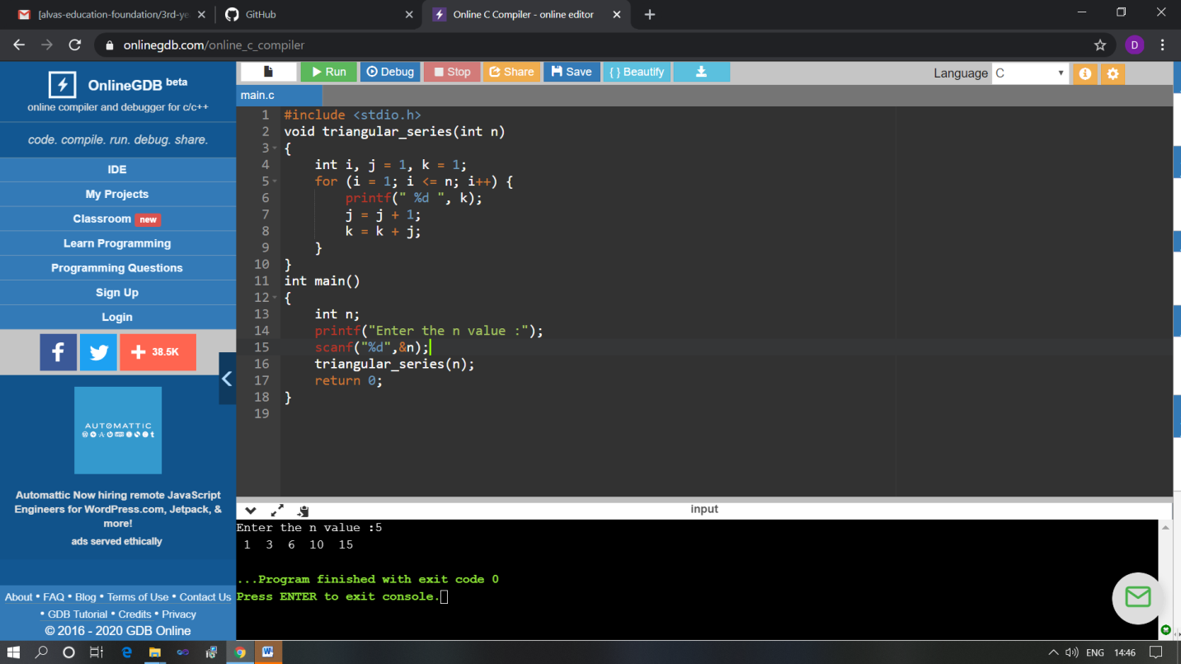

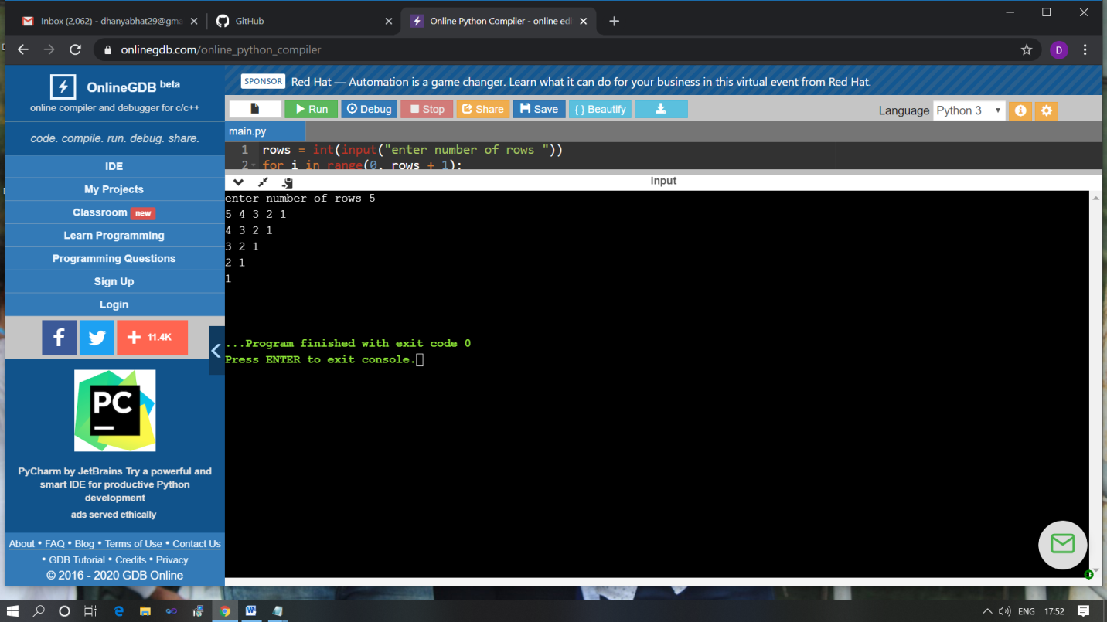

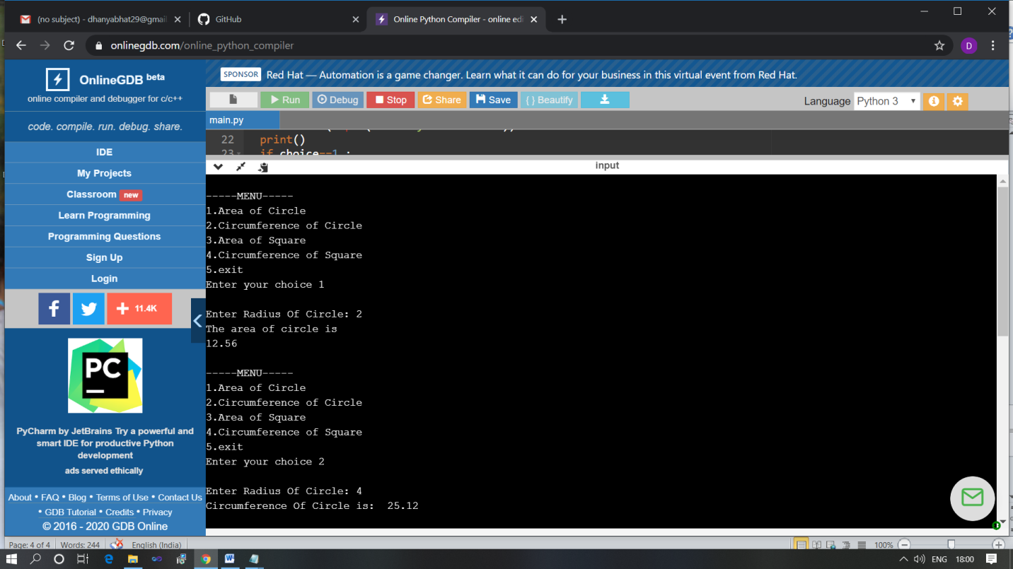

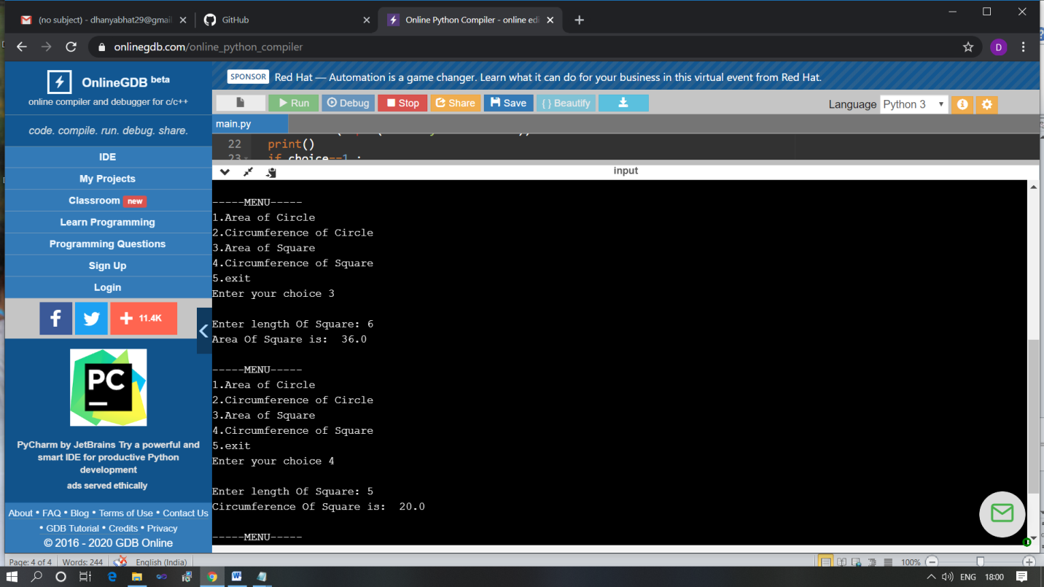

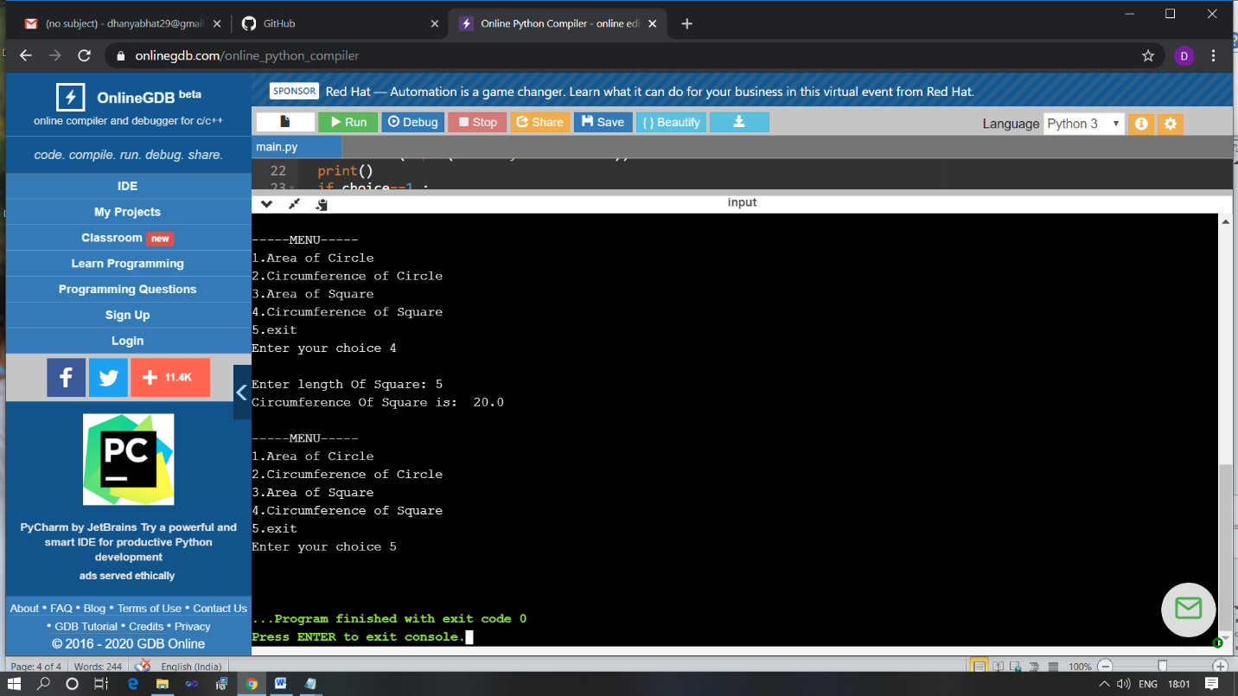

The above Programs were written and executed and the output of the same is displayed above. The code for those 3 programs have been uploaded to the github repository and the link to the same is provided on the form